Bangladesh Medical Association (BMA)
List of Life Member-108
17. BMA Faridpur Branch

Sl No | Voter No | Voter Details
1 | Voter No  LM-1700001  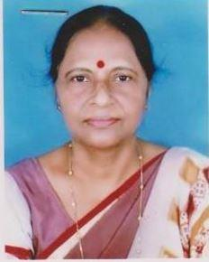 | DR. ANIMA RANI DAS  F/Name:  M/Name:  BM & DC Reg. No:  NID:  Cell:  Address: Gynae Specialist General Practitioner Faridpur  Blood Group:
2 | Voter No  LM-1700002  No Image | DR. SOHAIL ALLY  F/Name:  M/Name:  BM & DC Reg. No:  NID:  Cell:  Address: Jhiltuli, Faridpur.  Blood Group:
3 | Voter No  LM-1700003  No Image | DR. RIZIA ALAM  F/Name:  M/Name:  BM & DC Reg. No:  NID:  Cell:  Address: MCWC Jhiltuli, Faridpur.  Blood Group:
4 | Voter No  LM-1700004  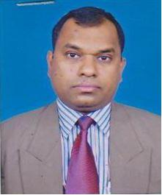 | DR. MRITUNJOY SAHA  F/Name:  M/Name:  BM & DC Reg. No:  NID:  Cell:  Address: Rajendra Pharmacy Niltuly, Faridpur.  Blood Group:
5 | Voter No  LM-1700005  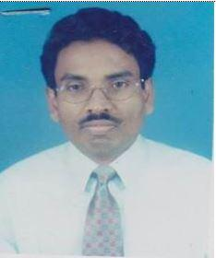 | DR. SHANKAR KUMAR DEY  F/Name:  M/Name:  BM & DC Reg. No:  NID:  Cell:  Address: Chief Medical Officer (Ex. Direc) Nuclear Medicine Centre, Faridpur  Blood Group:
6 | Voter No  LM-1700006  No Image | DR. MD. AMINUR RAHMAN  F/Name: A.M. Majibur Rahman  M/Name:  BM & DC Reg. No: 18709  NID:  Cell:  Address: Asstt. Registrar (Ortho, Surgery) Faridpur.  Blood Group:
7 | Voter No  LM-1700007  No Image | DR. ABDUS SAMAD SHAIKH  F/Name:  M/Name:  BM & DC Reg. No:  NID:  Cell:  Address: Associate Professor, ENT Faridpur Medical College, Faridpur.  Blood Group:
8 | Voter No  LM-1700008  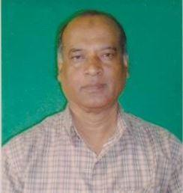 | DR. S.M. SIRAJUL AREFIN  F/Name:  M/Name:  BM & DC Reg. No:  NID:  Cell:  Address: Associate Professor Of ENT Faridpur Medical College Hospital, Faridpur.  Blood Group:
9 | Voter No  LM-1700009  No Image | DR. MD. RAFIQUL ISLAM  F/Name:  M/Name:  BM & DC Reg. No:  NID:  Cell:  Address: Lecturer Community Medicine Faridpur Medical College Faridpur.  Blood Group:
10 | Voter No  LM-1700009  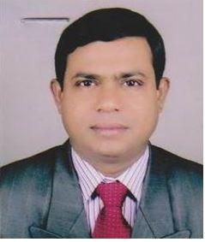 | DR. RAFIQUL ISLAM  F/Name:  M/Name:  BM & DC Reg. No:  NID:  Cell:  Address: Lecturer Community Medicine Faridpur Medical College Faridpur.  Blood Group:
11 | Voter No  LM-1700010  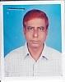 | DR. MD. SHAMSUL HOQUE  F/Name:  M/Name:  BM & DC Reg. No:  NID:  Cell:  Address: Associate Prof., Ophthalamology Faridpur Medical College Faridpur.  Blood Group:
12 | Voter No  LM-1700011  No Image | DR. SHYAMAL KUMAR SAHA  F/Name: Late Gouranga Bihari Saha  M/Name:  BM & DC Reg. No: 14355  NID:  Cell:  Address: Asstt. Prof. Of Paediatrics Dept. Faridpur Medical College Hospital, Faridpur.  Blood Group:
13 | Voter No  LM-1700012  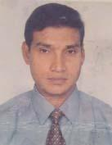 | DR. S. M. KHABIRUL ISLAM  F/Name: Late S M Joynul Abedin  M/Name: Kulsum Begum  BM & DC Reg. No: 16182  NID:  Cell: 01711896957  Address: Asst.Prof. Dept. of Forensic Medicine, Faridpur Medical College Hospital,Faridpur.  Blood Group:
14 | Voter No  LM-1700013  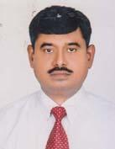 | DR. ALOKE KUMAR SAHA  F/Name: Late. Hari Prosad Saha  M/Name: Momota Rani Saha  BM & DC Reg. No: 1965  NID: 4421902109518  Cell: 01711806903  Address: Flat-702, Building No- 19, Japan Garden City, Mohammaedpur, Dhaka.  Blood Group: O+
15 | Voter No  LM-1700014  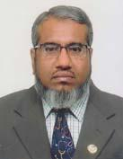 | DR. SK. ABDUL FATTAH  F/Name: Sk. Sydul Islam  M/Name: Feroza Begum  BM & DC Reg. No: 16033  NID: 4421902109831  Cell: 01720093545  Address: Assoc. Prof. Medicine Faridpur Medical College Hospital, Faridpur.  Blood Group: B+
16 | Voter No  LM-1700015  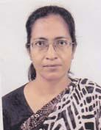 | DR. SHILA RANI DAS  F/Name: Late Shibendra Nath Das  M/Name: Renuka Bala Das  BM & DC Reg. No: 15673  NID:  Cell: 01712288609  Address: Faridpur Medical College Hospital, Faridpur.  Blood Group: O+
17 | Voter No  LM-1700016  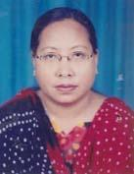 | DR. MINAKSHI CHAKMA  F/Name: Late. Kail Ratan Chakma  M/Name: Late, Niyoti Chakma  BM & DC Reg. No: 24236  NID: 2624703127435  Cell: 01712599054  Address: Junior Consultant Faridpur Medical College Hospital Faridpur.  Blood Group:
18 | Voter No  LM-1700017  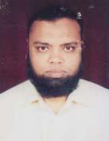 | DR. MD. ABUL KHAIR  F/Name: Md. Mokhlesur Rahman  M/Name: Mrs. Aleya Rahman  BM & DC Reg. No: 23266  NID:  Cell: 01711161112  Address: Assistant Professor(Urology) Faridpur Medical College Hospital Faridpur.  Blood Group: O+
19 | Voter No  LM-1700018  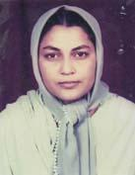 | DR. DILRUBA ZEBA  F/Name: Md. Abdur Razzaque  M/Name: Mrs. Shamsun Nahar  BM & DC Reg. No: 23267  NID: 2924704134276  Cell: 01712090825  Address: Asst. Prof (Gynae & Obst) Faridpur Medical College Hospital, Faridpur.  Blood Group: A+
20 | Voter No  LM-1700019  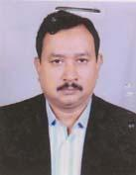 | DR. MD. FARID HOSSAIN MIAH  F/Name: Md. Abdul Wadud Miah  M/Name: Late- Zaheda Begum  BM & DC Reg. No: 19923  NID:  Cell: 01712509001  Address: UHC, Boalmari,, Faridpur  Blood Group: B+
21 | Voter No  LM-1700020  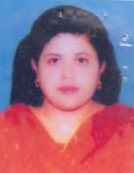 | DR. RAWSHAN ZAHAN AKHTER ALO  F/Name: Late Abdul Majid Mollah  M/Name: Mrs. Halima Majid  BM & DC Reg. No: 28940  NID: 2921805281472  Cell: 01711039558  Address: U.H.C, Boalmari, Faridpur  Blood Group: B+
22 | Voter No  LM-1700021  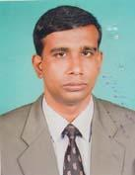 | DR. GIAS UDDIN AHMED  F/Name: Md. Rafiqul Islam  M/Name: Anowara Begum  BM & DC Reg. No: 27877  NID: 2697557395434  Cell: 01711979470  Address: Doctor\'s Quarter, Upazila Health Complex, Boalmari, Faridpur  Blood Group: B+
23 | Voter No  LM-1700022  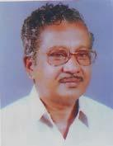 | DR. GURUDAS KARMAKER  F/Name: Late Dr. Dines Chandra Karmaker  M/Name: Late Ruhinibala Karmaker  BM & DC Reg. No: 1522  NID: 2924704133021  Cell: 01819401025  Address: 48/A Niltuli, Mujib Sarak, Faridpur.  Blood Group: B+
24 | Voter No  LM-1700023  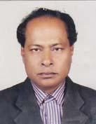 | DR. RAJMOHON HIRA  F/Name: Late Nimai Chandra Hira  M/Name: Late Banolata Hira  BM & DC Reg. No: 16236  NID: 0695120243368  Cell: 01712537095  Address: Asstt. Professor, Fmc Faridpur Medical College Faridpur  Blood Group: B+
25 | Voter No  LM-1700024 | DR. KAZI NAZIB HASAN  F/Name: Kazi Golam Mohiuddin  M/Name: Parvin Sultana  BM & DC Reg. No: 54711  NID: 2924705145693  Cell: 01717861131  Address: Amena Manjil, Tamijuddin Khan Road, Jhiltully, Faridpur  Blood Group: O+
26 | Voter No  LM-1700025  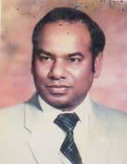 | DR. A.R MOLLAH BABUL  F/Name: Late Mvi. Abdul Aziz Mollah  M/Name: Late Mrs. Sokhina Begum  BM & DC Reg. No: 9001  NID: 2911835155729  Cell: 01710821044  Address: Maleqa Chokkhu Hashpatal, Boalmari, Wapda Morr, Faridpur  Blood Group: B+
27 | Voter No  LM-1700026  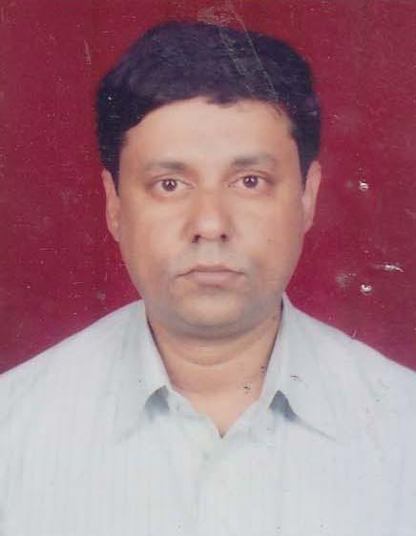 | DR. RATAN KUMAR SAHA  F/Name: Late Ramani Mohon Saha  M/Name: Juthika Rani Saha  BM & DC Reg. No: 19710  NID: 2924705145133  Cell: 01711420942  Address: Assistant Prof.Fmch, Surgery Faridpur.  Blood Group: A+
28 | Voter No  LM-1700027  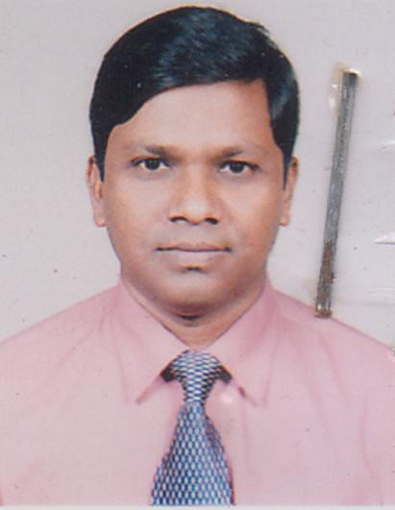 | DR. MD .KAMRUL HASSAN  F/Name: Md. Anwarul Islam  M/Name: Rahima Begum  BM & DC Reg. No: 22872  NID: 2924704131331  Cell: 01711-440443  Address: Associate Professor Dept. Of Shushu Surgery, Faridpur Medical College Hospital,Faridpur.  Blood Group: O+
29 | Voter No  LM-1700028  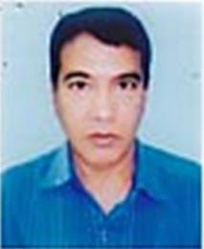 | DR. SUDHENDO PROKAS BISWAS  F/Name:  M/Name:  BM & DC Reg. No:  NID:  Cell:  Address: Professor Of Microbiology Dibetic Association Medical College, Faridpur.  Blood Group:
30 | Voter No  LM-1700029  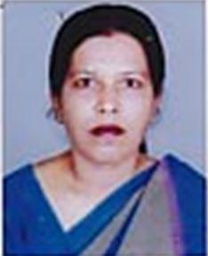 | DR. SHIPRA SINHA ROY  F/Name:  M/Name:  BM & DC Reg. No:  NID:  Cell:  Address: Professor Of Physiology Dibetic Association Medical College, Faridpur.  Blood Group:
31 | Voter No  LM-1700030  No Image | DR. MD. ENAMUL HOQUE  F/Name:  M/Name:  BM & DC Reg. No:  NID:  Cell:  Address: Senior Consultant, Eye Department Faridpur Medical College Hospital, Faridpur.  Blood Group:
32 | Voter No  LM-1700031  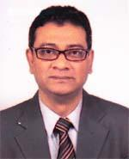 | PROF. DR. A. S. M. JAHANGIR CHOWDHURY TITO  F/Name: Late Dr. Abdus Salam Chowdhury  M/Name: Late Jahanara Begum  BM & DC Reg. No: 13231  NID: 2924705145113  Cell: 01711875537  Address: Professor of Orthopaedic Surgery, Faridpur Medical College  Blood Group: O+
33 | Voter No  LM-1700032  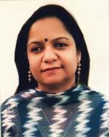 | DR. TAHMINA AKTER  F/Name: Md. Anisur Rahman Khan  M/Name: Late Samsu Nnahar  BM & DC Reg. No: 30986  NID: 2924703127147  Cell: 01710989403  Address: Associate Professor of Paediatics Diabetic Association Medical College, Faridpur  Blood Group: O+
34 | Voter No  LM-1700033  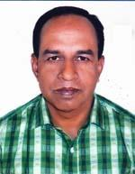 | DR. MD. MAHFUZUR RAHMAN BULU  F/Name: Late Md. A. Hakim Mia  M/Name: Late Morium Begum  BM & DC Reg. No: 27883  NID: 2924703127174  Cell: 01715342774  Address: Medical Office , FMCH, Faridpur  Blood Group: O+
35 | Voter No  LM-1700034  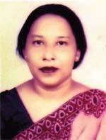 | DR. ZEBUNNESSA PARVIN  F/Name: Akkel Ali  M/Name: Amir Unnessa  BM & DC Reg. No: 13230  NID: 2924704131460  Cell: 01711123833  Address: Serene 42/1/A, Master Firoz Rahman Road, Jhiltuli, Faridpur  Blood Group: O+
36 | Voter No  LM-1700035  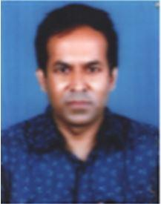 | DR. MD. NAZRUL ISLAM  F/Name: Md. Rustom Ali  M/Name: Mrs. Sayaatunnesa  BM & DC Reg. No: 39821  NID: 2924708169557  Cell: 01711174044  Address: Rowsan Khan Sarak, Alipur, Faridpur  Blood Group: O+
37 | Voter No  LM-1700036  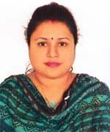 | DR. LOPA SEN GUPTA  F/Name: Late Badal Sen Gopta  M/Name: Shapna Sen Gupta  BM & DC Reg. No: 53109  NID: 9196203131821  Cell: 01711942465  Address: West end Para, Post-Sreenagar, Goalchamot, P.s-Kotowaly, Dist-Faridpur  Blood Group: B+
38 | Voter No  LM-1700037  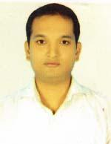 | DR. UTPAL NAG  F/Name: Himangsu Kumar Nag  M/Name: Kalpana Nag  BM & DC Reg. No: 40344  NID: 2924702114179  Cell: 01711449529  Address: West end Para, Post-Sreeaumgar, Goalchamot, P.s-Kotowali, Dist-Faridpur  Blood Group: A+
39 | Voter No  LM-1700038  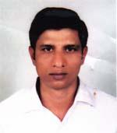 | DR. NAKUL RANGON SARKAR  F/Name: Late Narayon Chandra Sarkar  M/Name: Subhodra Rani Sarkar  BM & DC Reg. No: 28850  NID: 2924705144795  Cell: 01711465603  Address: Dr. Zahid Memorial Child Hospital, Faridpur.  Blood Group: A+
40 | Voter No  LM-1700039  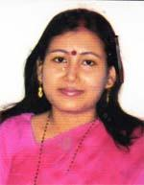 | DR. LIPIKA SANJOWAL  F/Name: Bimalendu Sanjowal  M/Name: Bahroti Roy  BM & DC Reg. No: 42708  NID: 2924705145303  Cell: 01748500385  Address: Asso. Prof. Dept. of Anasthulogy, Faridpur Medical College, Faridpur.  Blood Group: AB+
41 | Voter No  LM-1700040  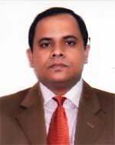 | DR. SWAPAN KUMAR BISWAS  F/Name: Sushil Kumar Biswas  M/Name: Debobala Biswas  BM & DC Reg. No: 28138  NID: 2924705145304  Cell: 01712120828  Address: Asst. Prof. Dept. of Surgery, Faridpur Medical College Faridpur.  Blood Group: B+
42 | Voter No  LM-1700041  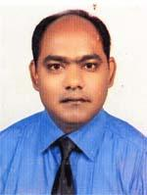 | DR. BIJOY KUMAR SAHA  F/Name: Ajit Kumar Saha  M/Name: Gita Rani Saha  BM & DC Reg. No: 35939  NID: 2924702114667  Cell: 01711314703  Address: Sree Angon South Palli, Goalchamot, Faridpur.  Blood Group: AB+
43 | Voter No  LM-1700042  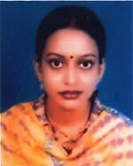 | DR. PURABI SARKAR  F/Name: Dilip Kumar Sarkar  M/Name: Shakti Sarkar  BM & DC Reg. No: 40761  NID: 2924702114666  Cell: 01711073718  Address: Vill-Goal Chamat, (Khodabox Road) Post-Sree Angon, Dist-Faridpur  Blood Group: A+
44 | Voter No  LM-1700043  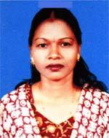 | DR. GITA GAIN  F/Name: Amar Chand Gain  M/Name: Kanok Lata Gain  BM & DC Reg. No: 24781  NID: 2924707156093  Cell: 01711232725  Address: Paricharja Hospital Limited, Goalchamot, Faridpur  Blood Group: O+
45 | Voter No  LM-1700044  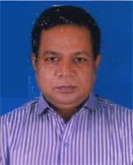 | DR. MOHAMMAD ABU BAKAR SIDDIQUE  F/Name: Late Md, Kabir Hossain Mia  M/Name: Late Sabera Khatun  BM & DC Reg. No: 20964  NID: 2695044886190  Cell: 01712032242  Address: Faridpur Medical College  Blood Group: A+
46 | Voter No  LM-1700045  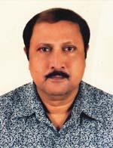 | DR. NIRANJAN KUMAR DAS  F/Name: Late Shanti Pada Das  M/Name: Ranu Bala Das  BM & DC Reg. No: 21465  NID:  Cell: 01715035380  Address: Faridpur Sadar, Faridpur  Blood Group: AB+
47 | Voter No  LM-1700046  No Image | ***NIL***  F/Name:  M/Name:  BM & DC Reg. No:  NID:  Cell:  Address:  Blood Group:
48 | Voter No  LM-1700047  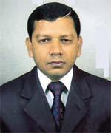 | DR. SYED OBYDUR RAHMAN  F/Name: Syed Nawsar Ali  M/Name: Komala Begum  BM & DC Reg. No: 26475  NID: 2911875243792  Cell: 01711282445  Address: Zaman Tower, Jheeltuly , Faridpur  Blood Group: B+
49 | Voter No  LM-1700048  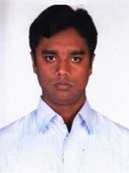 | DR. SYED HASANUL KABIR  F/Name: Sayed Rezaul Haque  M/Name: Mrs. Hasna Hena  BM & DC Reg. No: 59160  NID: 2691647440130  Cell: 01717173311  Address: East Alipur, Faridpur  Blood Group: O+
50 | Voter No  LM-1700049  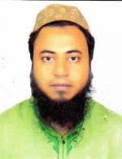 | DR. A. S. M TANJILUR RAHMAN  F/Name: Md. Ismail Hossain  M/Name: Mrs. Hasna Ismail  BM & DC Reg. No: 39309  NID: 19792697557395527  Cell: 01711965277  Address: Faridpur Medical College Hospital, Faridpur  Blood Group: A+
51 | Voter No  LM-1700050  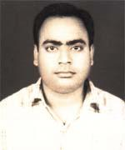 | DR. MASOOD AZIZ  F/Name: Mosi Hur Rahman  M/Name: Zarina Rahman  BM & DC Reg. No: 25921  NID: passportnoa095  Cell: 01621973163  Address: Kanak Nibas, 123 Niltuli, Faridpur.  Blood Group: A+
52 | Voter No  LM-1700051  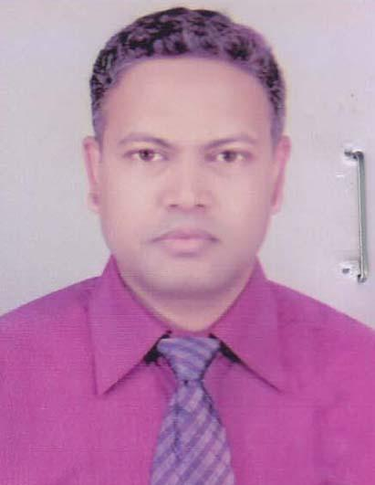 | DR. MD. KAMRUJJAMAN  F/Name: Md. Nasiruddin  M/Name: Mrs. Jamena Begum  BM & DC Reg. No: 32170  NID: 5519531444624  Cell: 01711986514  Address: 2 No. Ukil Para, Jheltuly, Faridpur  Blood Group: O+
53 | Voter No  LM-1700052  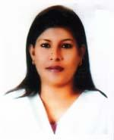 | DR. FAHMIDA ZESMIN  F/Name: Abdul Haque  M/Name: Salma Khanam  BM & DC Reg. No: 35459  NID: 2693624778625  Cell: 01711022662  Address: Hello World, 3 No Shamsuddin Tower, Alipur Mor, Faridpur  Blood Group: A+
54 | Voter No  LM-1700053  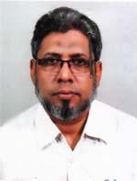 | DR. MOLLA SHARFUDDIN AHMED  F/Name: Late Molla Shamsuddin Ahmad  M/Name: Late Sufia Khanam  BM & DC Reg. No: 18979  NID: 2694069240244  Cell: 01712022764  Address: General Hospital, Faridpur  Blood Group: O+
55 | Voter No  LM-1700054 | DR. MD. EMRAN ALI  F/Name: Md. Omed Ali  M/Name: Mosa. Zohurun Nesa  BM & DC Reg. No: 15650  NID: 5428705650566  Cell: 01717249177  Address: Superintendent NIDCH Mohakhali, Dhaka.  Blood Group: O+
56 | Voter No  LM-1700055 | DR. MOHAMMAD SHAHIN AKHTER  F/Name: Md. Abul Hossen Jobber  M/Name: Mst. Rokeya Begum  BM & DC Reg. No: 37081  NID: 2914715258400  Cell: 01915932111  Address: Sotowri Faridpur Tower, Faridpur  Blood Group: A+
57 | Voter No  LM-1700056  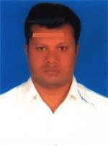 | DR. SAYED GOLAM RABBANI  F/Name: Talukder Enayet Hossen  M/Name: Husneara Begum  BM & DC Reg. No: 46851  NID: 2911047696451  Cell: 01865001478  Address: Darpan, H/O-23/23/C, Road No.-2, Battala West Khabarpur, Kotoali, Faridpur.  Blood Group: A+
58 | Voter No  LM-1700057  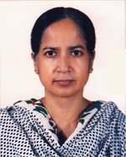 | DR. MST. FEROZA BEGUM  F/Name: Late Fazlur Rahman  M/Name: Jahera Khatun  BM & DC Reg. No: 21463  NID: 2924705144933  Cell: 01716839940  Address: 63/B, 7/A, T-2, Washith Tower, Jhiltuli, Faridpur  Blood Group: A+
59 | Voter No  LM-1700058 | DR. MD. ABDUL MOMIN KHAN  F/Name: Mr. Md. Moniruzzaman Khan  M/Name: Mrs. Amena Khan  BM & DC Reg. No: 52628  NID: 2610457996105  Cell: 01937676733  Address: Shahid Ziaur Rahman Medical College, Bogra  Blood Group: A+
60 | Voter No  LM-1700059  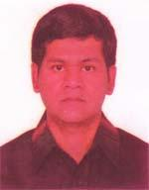 | DR. MD. TOWRIT REZA  F/Name: Late Dr. Abdur Razzaque  M/Name: Late Selina Begum  BM & DC Reg. No: 28302  NID: 2924704131495  Cell: 01918312903  Address: 40/4/A, Jheeltuly, Faridpur  Blood Group: B+
61 | Voter No  LM-1700060  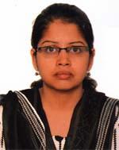 | DR. NAZMUN NAHAR  F/Name: Mozharul Hannan  M/Name: Shahanara Begum  BM & DC Reg. No: 40010  NID: 2924704131497  Cell: 01714097894  Address: 40/4/A, Jheeltuly, Faridpur  Blood Group: A+
62 | Voter No  LM-1700061 | DR. TRISHA SARKER  F/Name: Tarapada Sarkar  M/Name: Arpana Rani Sarkar  BM & DC Reg. No: 69246  NID: 6916336238722  Cell: 01624875150  Address: R.N Plaza (1st Floor), Jhiltuly, Faridpur.  Blood Group: A+
63 | Voter No  LM-1700062 | DR. DIPON KUMAR DAS  F/Name: Kashi Nath Das  M/Name: Rani Das  BM & DC Reg. No: 51580  NID: 2924704135783  Cell: 01558554846  Address: R.N Plaza (1st Floor), Jhilltuly, Faridpur  Blood Group: O+
64 | Voter No  LM-1700063  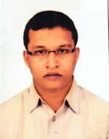 | DR. MUHAMMAD ARIF HOSSAIN  F/Name: Muhmmad Atahar Hossain  M/Name: Nasima Begum  BM & DC Reg. No: 61952  NID: 2915652123138  Cell: 01717300851  Address: Vill-Bonnomalidia, Post-Modhukhali, Thana-Modhikhali, Dist-Faridpur  Blood Group: O+
65 | Voter No  LM-1700064  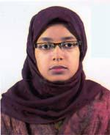 | DR. AFROZA SULTANA  F/Name: Alef Matubbor  M/Name: Shamsunnaher  BM & DC Reg. No: 62568  NID: 292470703122724  Cell: 01723612129  Address: Hospital Quarter, Ground Floor Sadarpur UHC, Faridpur  Blood Group: O+
66 | Voter No  LM-1700065  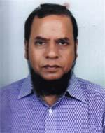 | DR. EMERITUS SK. YUNUS ALI  F/Name: Late Md. Iman Ali Shaikh  M/Name: Late Momena Khatun  BM & DC Reg. No: 12188  NID:  Cell: 01711208966  Address: Faridpur, Medical College, Faridpur  Blood Group: B+
67 | Voter No  LM-1700066  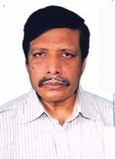 | DR. RADHESHYAM SAHA  F/Name: Late Sreedan Chandra Saha  M/Name: Mrs. Surabala Saha  BM & DC Reg. No: 15775  NID: 29247041310198  Cell: 01711883080  Address: Wirelesspara, Goalchamot Faridpur.  Blood Group: O+
68 | Voter No  LM-1700067  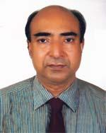 | PROF. DR. JITESH CHANDRA SAHA  F/Name: Dr. Joytish Chandra Saha  M/Name: Reba Rani Saha  BM & DC Reg. No: 11215  NID: 2924704131086  Cell: 01711431902  Address: 5, Mosjid Road, Jhiltuly, Faridpur  Blood Group: AB+
69 | Voter No  LM-1700068  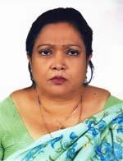 | PROF. DR. DIPTI PRAMANIK  F/Name: Late Rabindranath Pramanik  M/Name: Tripti Pramanik  BM & DC Reg. No: 13174  NID: 2924704131092  Cell: 01720238839  Address: 5, Mosjid Bari Road, Jhiltuly, Faridpur  Blood Group: A+
70 | Voter No  LM-1700069  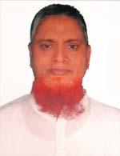 | DR. MD. ZOHIRUL ISLAM MIAH  F/Name: Late Abdur Rahman Miah  M/Name: Late Noorjahan Begum  BM & DC Reg. No: 18835  NID: 2924704131934  Cell: 01712007517  Address: 1/17/Kha, Abdul Karim Miah Sarak, Jheeltuly, Faridpur  Blood Group: O+
71 | Voter No  LM-1700070  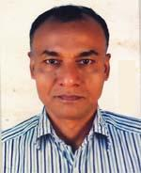 | DR. ANADI RANJAN MONDAL  F/Name: Dhirendra Nath Mondal  M/Name: Karuna Mandal  BM & DC Reg. No: 17096  NID: 2924704131877  Cell: 01715090022  Address: Jhiltuly, Faridpur  Blood Group: B+
72 | Voter No  LM-1700071  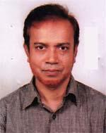 | DR. MD. YUSUF ALI  F/Name: Late Yeakub Ali  M/Name: Late Shahera Khatun  BM & DC Reg. No: 11338  NID: 2924705144822  Cell: 0171142512  Address: Arrogga Saon Mujib Sarac Jhiltali, Faridpur  Blood Group: B+
73 | Voter No  LM-1700072  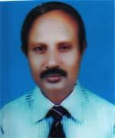 | DR. BISWANATH ROY  F/Name: Baiddya Nath Roy  M/Name: Anima Roy  BM & DC Reg. No: 17993  NID: 2924702113256  Cell: 01711197518  Address: Roy House, Rakhaldas Sarak, Singpara, Goalchamot, Faridpur  Blood Group: AB+
74 | Voter No  LM-1700073  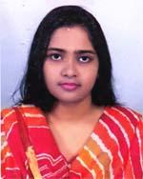 | DR. TASNIMA HASSAN  F/Name: Md. Imdadul Hassan  M/Name: Lovely Hassan  BM & DC Reg. No: 71449  NID: 19922924709000008  Cell: 01672781323  Address: 2 No. Habeli Gopalpur, Post-Faridpur, P.s-Kotowali, Dist-Faridpur  Blood Group: B+
75 | Voter No  LM-1700074  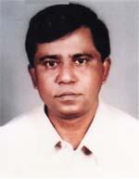 | DR. MD. ABU SALEQUE  F/Name: Late Md. Abdul Hye  M/Name: Rokeya Begum  BM & DC Reg. No: 10376  NID: 2924704136908  Cell: 01817509107  Address: Vill. East Khabashpur, Post & Dist-Faridpur  Blood Group: O+
76 | Voter No  LM-1700075  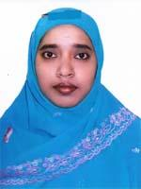 | DR. NASRIN AKTER RUBY  F/Name: Idris Ali Sarder  M/Name: Nargis Akter  BM & DC Reg. No: 40286  NID: 2694811039977  Cell: 01558596598  Address: Jhiltuly , Faridpur  Blood Group: O+
77 | Voter No  LM-1700076 | DR. MD. SHAFIQUR RAHMAN  F/Name: Late Abdur Rahman  M/Name: Late Wazaeda Begum  BM & DC Reg. No: 22193  NID: 2924709170074  Cell: 01718308225  Address: 5/12/1-A, Yuho Laxmipur, Faridpur  Blood Group: A+
78 | Voter No  LM-1700077  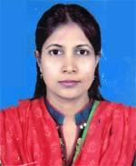 | DR. SAMIYA ALAM  F/Name: Md. Shamsul Alam  M/Name: Ayesha Begum  BM & DC Reg. No: 28617  NID: 19732924705145897  Cell: 01912548256  Address: flat No.-5/B, Swapnonibash, South Jheltali, Faridpur,  Blood Group: B+
79 | Voter No  LM-1700078  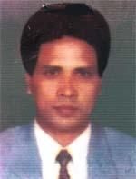 | DR. MD. MOHASIN BAIG  F/Name: Abdul Mannan Baig  M/Name: Anawara Begum  BM & DC Reg. No: 19307  NID: 2696828683208  Cell: 01711528559  Address: Anawara Hamida Lane Hospital, West Khabsspur, Faridpur  Blood Group: A+
80 | Voter No  LM-1700079  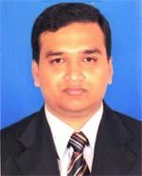 | DR. ABU FAISAL MD. PERVEZ  F/Name: Jalaluddin Ahmed  M/Name: Zinnat Afza  BM & DC Reg. No: 31266  NID: 2924704132798  Cell: 01712025076  Address: Flat No. E-6, 5th Floor, Wasith Tower-2, Faridpur  Blood Group: A+
81 | Voter No  LM-1700080  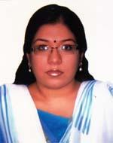 | DR. SUNANDA BISWAS  F/Name: Sudhendu Prakash Biswas  M/Name: Shipra Sinha Roy  BM & DC Reg. No: 69723  NID: 0695112193214  Cell: 01716717224  Address: Lecturer of Physiology Diabetic Association Medical College , Faridpur  Blood Group: B+
82 | Voter No  LM-1700081  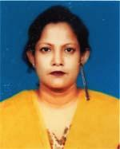 | DR. LUTFUN NAHER  F/Name: Late Md. Ismail Hossain  M/Name: Mrs. Nasimon Nesa  BM & DC Reg. No: 15977  NID: 2650898262114  Cell: 01712885515  Address: G.C. Roy Lane, Niltaly, Faridpur  Blood Group: O+
83 | Voter No  LM-1700082  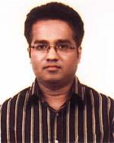 | DR. MOHAMMAD OMAR FAISAL  F/Name: Mohammad Nurul Alam  M/Name: Ayesha Begum  BM & DC Reg. No: 41111  NID: 19828524906077733  Cell: 01717525397  Address: Sadarpur Upazilla Health Complex, Faridpur  Blood Group: A+
84 | Voter No  LM-1700083  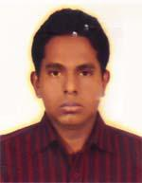 | DR. ARMAN HOSSAIN  F/Name: Md. Shaokat Ali  M/Name: Shajeda Begum  BM & DC Reg. No: 56218  NID: 0695111185328  Cell: 01837108997  Address: Dortor\'s Quarter, Upzilla Health Complex, Sadarpur, Faridpur  Blood Group: O+
85 | Voter No  LM-1700084  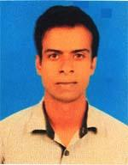 | DR. A. S. M MOSADDEK HOSSAIN KHAN  F/Name: Tarik Hossain Khan  M/Name: Shahana Begum  BM & DC Reg. No: 77570  NID: 19900695111000182  Cell: 01797325741  Address: Ward No.-5, Kamlapur, Post-Faridpur, Upazilla-Faridpur Sadar, Dist-Faridpur  Blood Group: O+
86 | Voter No  LM-1700085  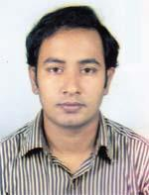 | DR. FARID AHMED  F/Name: Md. Jabed Ali  M/Name: Fatema Begum  BM & DC Reg. No: 62567  NID: 2924709173363  Cell: 01687416941  Address: Hospital Quarter, Ground Floor(old Building), Faridpur  Blood Group: A+
87 | Voter No  LM-1700086  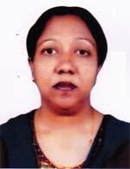 | DR. SHAHANA SULTANA  F/Name: Late A. Hasim  M/Name: Mrs. Fatema Begum  BM & DC Reg. No: 18693  NID: 2924105144823  Cell: 01711987465  Address: M.O. Chmic, Metanal & Child Walface Centre, Faridpur Sadar, Faridpur  Blood Group: A+
88 | Voter No  LM-1700087  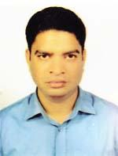 | DR. ABU AHMED ABDULLAH  F/Name: Abdul Hossain Sikder  M/Name: Nurunnahar Begum  BM & DC Reg. No: 28619  NID: 19722924705144522  Cell: 01911008674  Address: Flat No. 5/B, Swapnonibash, South Jheltali, Faridpur  Blood Group: A+
89 | Voter No  LM-1700088  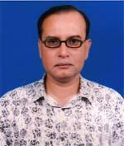 | DR. MD. HAFIZUR RAHMAN  F/Name: Late Tozammel Hossain  M/Name: Begum Noor Jahan  BM & DC Reg. No: 22258  NID: 292620800578  Cell: 01711235280  Address: Institute of Nuclear Medicine & allied Sciences, Faridpur  Blood Group: B+
90 | Voter No  LM-1700089 | DR. MOHAMMAD TAUHIDUL ISLAM  F/Name: Mohammad Abu Sayed Miah  M/Name: Anowara Begum  BM & DC Reg. No: 53092  NID: 6716822698833  Cell: 01714532355  Address: Senior Medical Officer, Diabetic Medical College Hospital, Faridpur  Blood Group: O+
91 | Voter No  LM-1700090  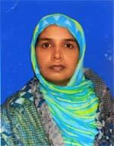 | DR. AFROZA AKTER  F/Name: Md. Mahbub Ali  M/Name: Mrs. Julekha Begum  BM & DC Reg. No: 42191  NID: 19782699039000019  Cell: 01716258152  Address: Doctors Quater UHC, Faridpur  Blood Group: A+
92 | Voter No  LM-1700091 | DR. SUPORNA LATIF AHMED  F/Name: Dr. Md. Abdul Latif  M/Name: Mrs. Kamrunnahar  BM & DC Reg. No: 59161  NID: 269164743896  Cell: 01747406277  Address: East alipur, Faridpur  Blood Group: O+
93 | Voter No  LM-1700092  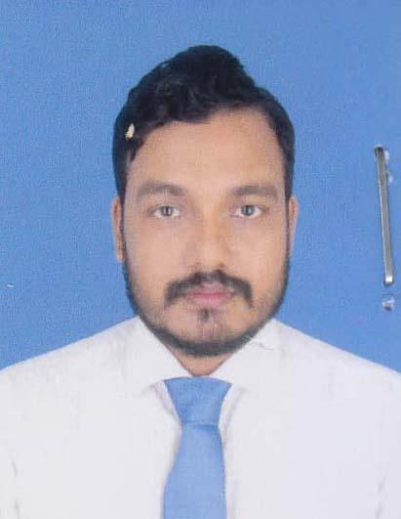 | DR. PARTHA PRATIM KARMAKER  F/Name: Badal Karmaker  M/Name: Gita Karmaker  BM & DC Reg. No: 50165  NID: 9196203132194  Cell: 01717364700  Address: 43, Ambika Sarak, Jhiltuli,Faridpur.  Blood Group: O+
94 | Voter No  LM-1700093  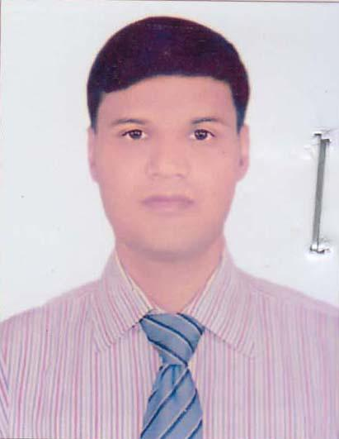 | DR. ASISH KUMAR SAHA  F/Name: Arabinda Saha  M/Name: Kanon Rani Saha  BM & DC Reg. No: 44233  NID: 2911031766671  Cell: 01717027661  Address: Nirmol Chandra Saha Road, Rathkhola, Goalchamot, Faridpur,  Blood Group: O+
95 | Voter No  LM-1700094  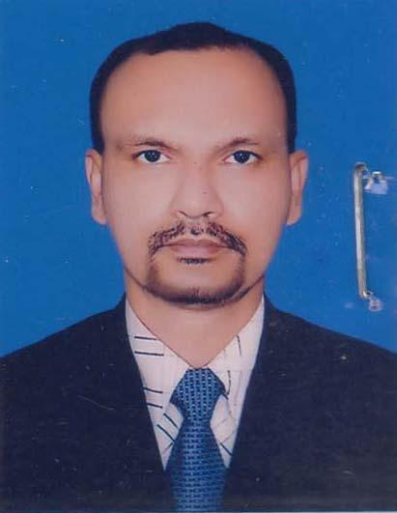 | DR. ANJAN KUMAR SAHA  F/Name: Arun Kumar Saha  M/Name: Nioty Rani Saha  BM & DC Reg. No: 42515  NID: 2698875745232  Cell: 01718086509  Address: Vill: Kishnardangi, P.O: Kunjanagor, P.S: Nagarkanda, Dist: Faridpur.  Blood Group: A+
96 | Voter No  LM-1700095  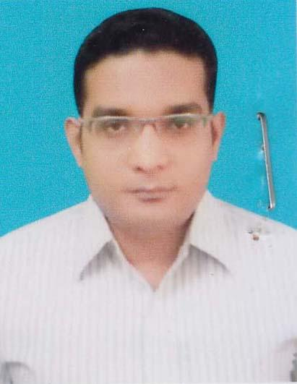 | DR. MOHAMMAD FARID UDDIN AHMED  F/Name: Abdul Bari Molla  M/Name: Begum Motia Bari  BM & DC Reg. No: 41411  NID: 2924707155262  Cell: 01757368972  Address: 154/1, Middle Alipur, Faridpur Sadar, Faridpur.  Blood Group: A+
97 | Voter No  LM-1700096  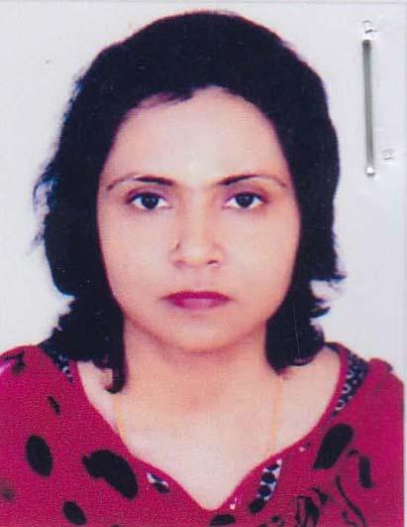 | DR. SABNAM SULTANA  F/Name: Late Abul Hasan Bhuiayn  M/Name: Shahida Begum  BM & DC Reg. No: 36815  NID: 0695119235157  Cell: 01711788705  Address: 2/11 Niketon, South Jhilltuly, Faridpur.  Blood Group: A+
98 | Voter No  LM-1700097  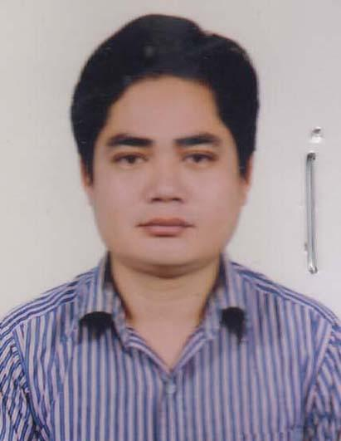 | DR. ARJUN DEB  F/Name: Chittaranjan Deb  M/Name: Sremoti Pran Bala  BM & DC Reg. No: 62105  NID: 19872924709173384  Cell: 01923007600  Address: Kaium Villa, Mia Para Sarak , Sadar, Faridpur.  Blood Group: A+
99 | Voter No  LM-1700098  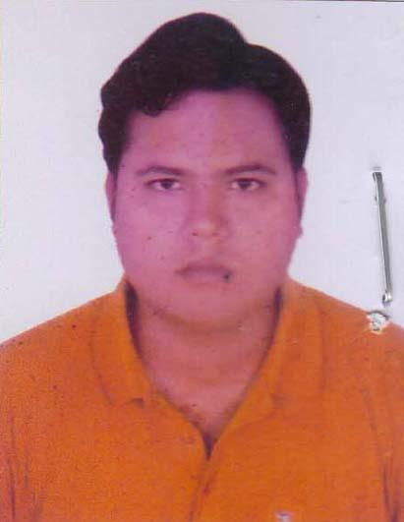 | DR. KAZI SABBIR HASAN  F/Name: Md. Abdul Barek Kazi  M/Name: Shahana Begum  BM & DC Reg. No: 62596  NID: 8198510364587  Cell: 01722387772  Address: Krisna Nagar, Faridpur Sadar, Faridpur.  Blood Group: A+
100 | Voter No  LM-1700099 | DR. MD. KAMRUJJAMAN  F/Name: Md. Nasiruddin  M/Name: Mrs. Jamena Begum  BM & DC Reg. No: 32170  NID: 55195-31444-624  Cell: 01711986514  Address: Eng. ASM Jaforullah, 2, Ukilpara, Jheeltuly,. Faridpur.  Blood Group: O+
101 | Voter No  LM-1700100  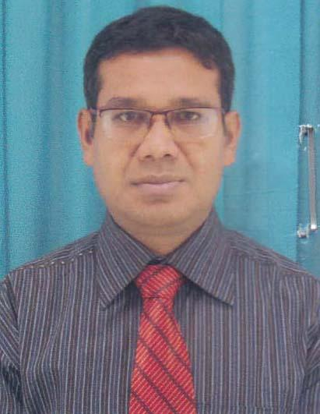 | DR. ANANTA KUMAR BISWAS  F/Name: Amal Krishna Biswas  M/Name: Parul Rani Biswas  BM & DC Reg. No: 34519  NID: 5525709152616  Cell: 01711735392  Address: Washith Tower-3, Flat-C/4, Jhiltuly, Faridpur-7800.  Blood Group: B+
102 | Voter No  LM-1700101  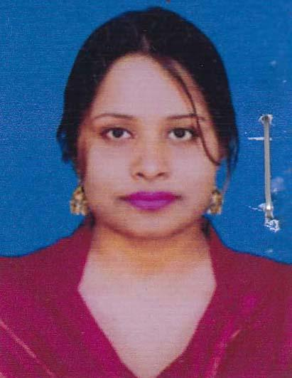 | DR. SWAPNA BISWAS JOY  F/Name: Sukumar Biswas  M/Name: Sneha Lata Biswas  BM & DC Reg. No: 37978  NID: 55257 09152 885  Cell: 01725069040  Address: Washith Tower-3, Flat-C/4, Jhiltuly, Faridpur.  Blood Group: O+
103 | Voter No  LM-1700102  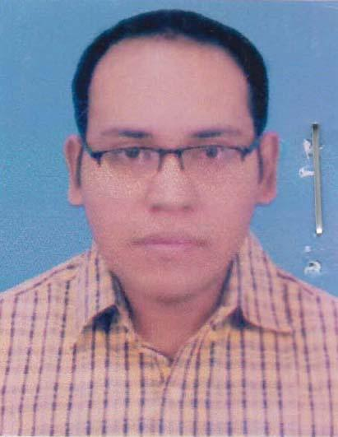 | DR.H.M. IMRAN HOSSAIN  F/Name: Md. Mokbul Hossain  M/Name: Najma Jahan  BM & DC Reg. No: 56043  NID: 4798516214729  Cell: 01717531004  Address: Kuthibari-2, Lazmipur, Fairdpur. Sadar, Faridpur.  Blood Group: B+
104 | Voter No  LM-1700103  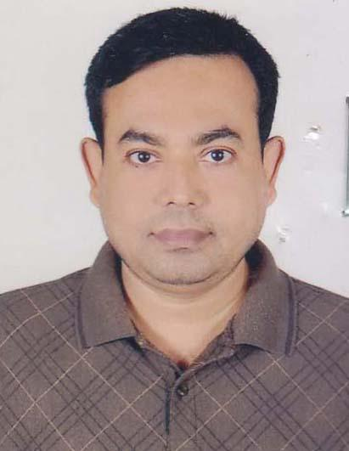 | DR. SANJOY KUMAR DAS  F/Name: Chittaranjan Das  M/Name: Anna Purna Das  BM & DC Reg. No: 35500  NID: 19772915684149688  Cell: 01712194279  Address: Baisakhi villa, Charkamlapur, Ramkrisna, Mission, Faridpur.  Blood Group: O+
105 | Voter No  LM-1700104  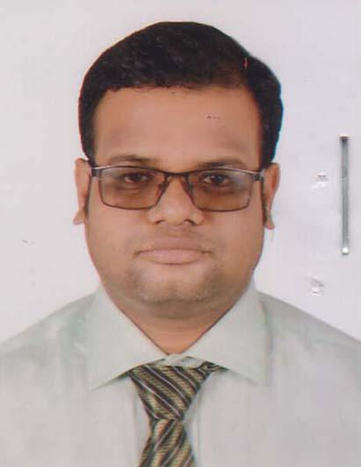 | DR. GOUTAM KUMAR SARKER  F/Name: Lakhan Chandra Sarker  M/Name: Miloni Rani Sarker  BM & DC Reg. No: 47016  NID: 2924706151130  Cell: 01717195339  Address: Vill: Deora P.O: Kafura, Upazilla: Faridpur, Sadar, Dist: Faridpur.  Blood Group: A+
106 | Voter No  LM-1700105  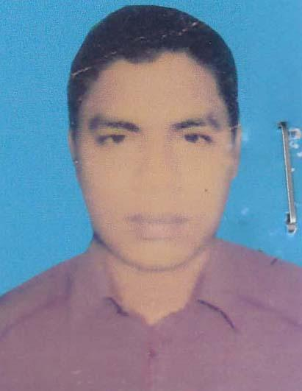 | DR. SUMON DAS  F/Name: Subhash Chandra Das  M/Name: Syamola Rani Das  BM & DC Reg. No: 59328  NID: 2915610041552  Cell: 01724984724  Address: Vill&P.O: Bagat, Thana: Madhukhali, Dist: Faridpur.  Blood Group:
107 | Voter No  LM-1700106  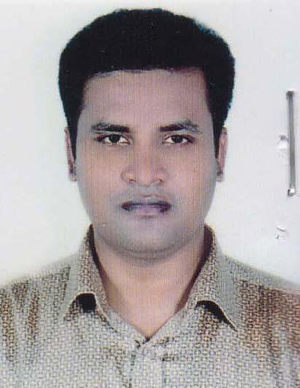 | DR. KHAN ABU DAUD  F/Name: Md. Hatem Ali  M/Name: Mrs. Kohinur Begum  BM & DC Reg. No: 52069  NID: 6115229552793  Cell: 01718050323  Address: Vill: Jhiltuly, Faridpur Sadar, Faridpur.  Blood Group: A+
108 | Voter No  LM-1700107  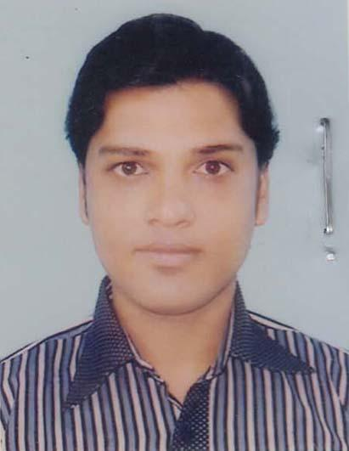 | DR. SHAHAN SAZEDUR RAHMAN  F/Name: Md. Abdul Jalil  M/Name: Shamsun Nahar  BM & DC Reg. No: 56933  NID: 6125217227384  Cell: 01718301253  Address: Holdin No. 34-2-5A, South Kali bari Road, Jhiltuly, Faridpur.  Blood Group: A+

